Four Cheese Garlic White Cream Pasta
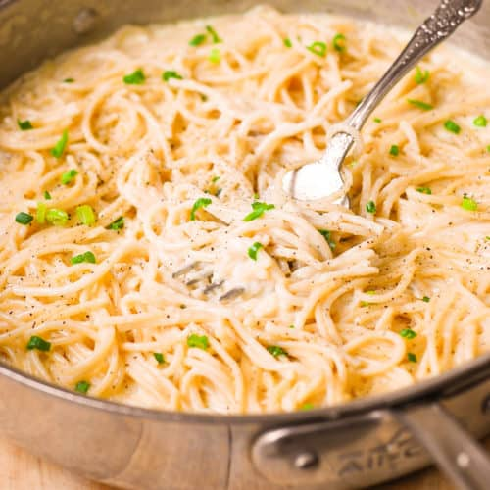
Prep Time 15 min Cook Time 20 min
6 Servings

Ingredients
1 Tbsp olive oil
1 Tbsp butter
5 garlic cloves minced
8 oz spaghetti
1 cup cooked pasta water
1 chicken bouillon cube
1 cup heavy cream
1 ½ cups Four-Cheese Italian White Cheese Blend (Mozzarella, White Cheddar, Provolone, Asiago)
Directions
- Heat olive oil and butter on medium heat in a large skillet, add minced garlic and cook for about 1 minute on medium heat, without burning.
- Cook pasta in a separate pan, drain.
- Reserve 1 cup of cooked pasta water and dissolve 1 cube of chicken broth bullion in the hot water.
- Add chicken broth/pasta water, heavy cream, and cooked spaghetti to the skillet with cooked garlic. Bring to boil, stirring.
- Immediately add cheese and keep stirring everything together, while boiling, until cheese melts and coats pasta, for about 1 minute. Reduce to simmer and continue to cook, constantly stirring, to thicken the sauce for another minute or two.

